**Information:**

Interview conducted with Interviewee 12 (male; data science)

39 minutes

Language spoken: Portuguese

Automatic transcription done with the software Happy Scribe, and checked by a coder.

Translations to the interviewee’s responses are provided in square brackets in grey.

**Follow-up to the survey on the use of machine translation in health contexts**

**Researcher:** Thank you again for accepting to participate in this interview. As you already know, this is a follow-up interview to the questionnaire on the use of machine translation in healthcare in the Netherlands. You replied to this questionnaire earlier this year. Let me start by reminding you that this interview is being recorded. The data collected will be anonymized and analyzed together with other participants’ data. The recording itself will never be published or shared, and it will be deleted as soon as it is transcribed and anonymized.

**Participant:** Ok. Obrigado.[Okay. Thank you.]

You are free to request a copy of the transcription. In the interview itself, we will invite you to go over potential scenarios regarding the use of technology - specifically, machine translation like Google translate or any other translation system on your phone or device - in healthcare contexts, like when you receive an invitation letter to get vaccinated or when you go to the doctor, huisarts.  The goal is to understand how machine translation can be used and what are the main challenges or opportunities when using it. We aim to create free training for users of machine translation like yourself in order to better support communities in these situations. The scenarios that we will show you are fictitious. They are potential scenarios or stories. The focus is on what you think a person would do if they were in this situation. Discuss anything that comes to mind or that you would like to share. We just ask you not to share confidential information about yourself.  If at any point, during the interview, you feel uncomfortable and you want to pause the interview, please just let us know. We can rephrase the question or stop the interview altogether. You can leave at any point during this interview. Any questions or concerns?

**Participant:** Sim, isto faz parte de um estudo maior? Como é que o contexto?[Yes, is this part of a larger study? What's the context like?]

**Researcher:** Sim, faz parte de um estudo maior em que a primeira fase foi o questionário a que respondeu. Neste momento, estamos na segunda fase das entrevistas, como esta hoje. Na equipa de investigação somos duas investigadoras. Eu, da Universidade de Leiden, e a minha colega Ana Guerberof, da Universidade de Groningen. Ambas somos especializadas em tradução, e este projeto foca-se no contexto de saúde e como é que migrantes não especializados em tradução lidam com os obstáculos linguísticos em contextos de saúde. Será que enfrentam obstáculos? Que tipo de obstáculos? O objetivo final é o de podermos oferecer formação às comunidades migratórias que vai ao encontro das suas necessidades. Estas informações também podem vir a ser importantes para informar a formação de futuros tradutores.[Yes, it's part of a larger study in which the first phase was the questionnaire you answered. We're currently in the second phase of the interviews, like this one today. There are two of us on the research team. Me, from Leiden University, and my colleague Ana Guerberof, from the University of Groningen. We both specialize in translation, and this project focuses on the health context and how migrants who don't specialize in translation deal with language barriers in health contexts. Do they face obstacles? What kind of obstacles? The ultimate goal is to be able to offer training to migrant communities that meets their needs. This information could also be important for informing the training of future translators.]

**Participant:** Obrigado.[Thank you.]

**[STAGE 1 SLIDE 2]**

**Researcher:** I will start now by reading the first scenario that you can also see on the screen.“Two years ago, Manuel moved to the Netherlands from Portugal. It was right amid the pandemic, and he moved to take up a position at a new company in Rotterdam. Manuel is a native speaker of Portuguese, and he also speaks English. He has taken two Dutch courses online, so he understands and speaks rudimentary Dutch. For example, he can ask for a drink or have short conversations with neighbors, but not enough to feel fully comfortable speaking Dutch fluently in all situations. In 2021, he received a letter from the RIVM inviting him to get vaccinated against COVID-19. The letter is in Dutch.” What do you think about this case?

**Participant:** Eu identifico-me bastante com a situação. Não, não mudei tão recentemente e consigo ler, mas identifico me bastante com a situação, acontece frequentemente.[I can identify with the situation a lot. No, I haven't moved [here] so recently and I can read, but I identify a lot with the situation, it happens often.]

**Researcher:** What do you think Manuel can do in this situation with the letter?

**Participant:** São duas, duas situações, não é? Hoje em dia, se fosse agora, não. Hoje em dia já iria ao Google, à Google Translate App tirava uma foto imediatamente traduzia, traduzia tudo. Essa é a primeira solução. Segundo, antes de (inaudível) essa app, o que eu fazia era primeiro tentava compreender um bocado da carta. Mas quando são assuntos de saúde, geralmente eu considero que são sempre bastante importantes. Se eu perceber que é importante e se não conseguir depreender o assunto, falo com alguém que conheço holandês e que me ajuda a traduzir e pelo menos me faz um breve sumário do que está lá.[It's two, two situations, isn't it? Not today, if it were now. Nowadays I'd go to Google, to the Google Translate App, take a photo and immediately translate, translate everything. That's the first solution. Secondly, before [inaudible] this app, what I did was first try to understand a bit of the letter. But when it comes to health issues, I generally think they're always quite important. If I realize that it's important and I can't understand it, I talk to someone who knows Dutch and who helps me translate and at least gives me a brief summary of what's in it.]

**Researcher:** Quando utiliza a app é no telemóvel? Como faz?[When you use the app, is it on your phone? How do you do it?]

**Participant:** Uso... Uso... Hoje em dia em movimento, porque só recentemente é que é que traduziu em movimento e que dava para fazer zoom. Antigamente dava, fazia a tradução automática, mas depois não dava para fazer zoom.[I use... I use it... Nowadays in motion [the “camera” option], because it was only recently that it translated in motion and zoomed in. In the past, it would translate automatically, but then you couldn't zoom in.]

**Researcher:** If you receive a letter from the RIVM in Dutch, what do you do?

**Participant:** Hoje em dia, tiro só a foto.[Nowadays, I just take the photo.]

**[STAGE 2 SLIDE 3]**

**Researcher: “**Because the letter mentioned COVID-19 and vaccinatie, and Manuel had been waiting for more information on when and how he could get vaccinated, it was very important for him to understand the letter completely and thoroughly in all its detail. He tackles this by trying to read the letter top to bottom, sentence by sentence. The letter is hard to understand. He does not know many of the words used, and he feels increasingly nervous.” Why do you think Manuel feels this way?

**Participant:** Não me identifico tanto porque acho que através da tradução já ou senão sem usar a tradução, já se consigo perceber relativamente bem que assunto é que tratam pelo menos com a minha base de holandês. Não consigo, não me relaciono tanto com esta situação.[I don't relate to it so much because I think that through translation, or even without translation, I can understand relatively well what they're talking about, at least with my knowledge of Dutch. I can't, I don't relate to this situation as much.]

**Researcher:** What would you recommend Manuel to do next?

**Participant:** Usar o Google Translate.[Use Google Translate.]

**[STAGE 3 SLIDE 4]**

**Researcher: “**Manuel decides to use Google Translate. He opens the app on his phone, and using the camera, he scans the letter. It is rather challenging.” How would you say his user experience with the app is?

**Participant:** Acho que isso depende um bocado da estratificação da população, não é? Há pessoas que já estão mais habituadas a usar o telefone. De certeza que vai ser mais fácil. Há pessoas que estão menos habituada a utilizar o telefone vai ser mais difícil. Mas acho que é relativamente relativamente simples. Aquilo é ligar e apontar.[I think it depends a bit on the stratification of the population, doesn't it? Some people are more used to using the phone. I'm sure it will be easier. There are people who are less used to using the phone and it's going to be more difficult. But I think it's relatively simple. You just open it and point.]

**Researcher:** What kind of problems do you think he might face with this technology?

**Participant:** Acho que um dos problemas que antes tinha era que era preciso mesmo fazer a foto para fazer o zoom. Não era... Não era um grande... Mas pronto, era mais uma, mais um passo que tinha de fazer e se calhar depois não dava para perceber tão bem, mas acho que são relativamente fáceis hoje em dia.[I think one of the problems I had before was that you really had to take the photo to zoom in. It wasn't... It wasn't a big... But there you go, it was one more step you had to take and maybe you didn't understand it [the translation] so well afterwards, but I think they're relatively easy nowadays.]

**[STAGE 4 SLIDE 5]**

**Researcher: “**Manuel is able to make an appointment for his vaccination. On the day of his appointment at the vaccination center, he goes to the counter, where he is asked in Dutch to present his ID and letter of invitation. He manages to understand this because the person on the counter makes a sign of the ID with his hand. Manuel is nervous. Next, he is asked to fill in a health questionnaire in Dutch.” What would you recommend Manuel to do next?

**Participant:** Se a pessoa falar, falar inglês ou se tiver uma língua em comum para comunicar. Estes questionários até nem sempre, mesmo na própria língua, são assim tão simples. Há sempre uma interação que ajuda a preencher com a ajuda da pessoa, mas se a pessoa estiver muito ocupada, [inaudível] usar a, usar a app.[If the person speaks, speaks English or has a common language to communicate in. These questionnaires aren't always that simple, even in your own language. There's always an interaction that helps you fill it out with the help of the person, but if the person is very busy, [inaudible] use the, use the app.]

**[STAGE 5 SLIDES 6-8]**

**Researcher:** “Because he has some knowledge of Dutch, and the first questions in the form do not appear to be difficult, such as *Naam,* *Achternaam*, Manuel tries to answer them in Dutch. On the second page, though, he reads three questions he does not understand. He does not understand questions 11, 12 and 13.”

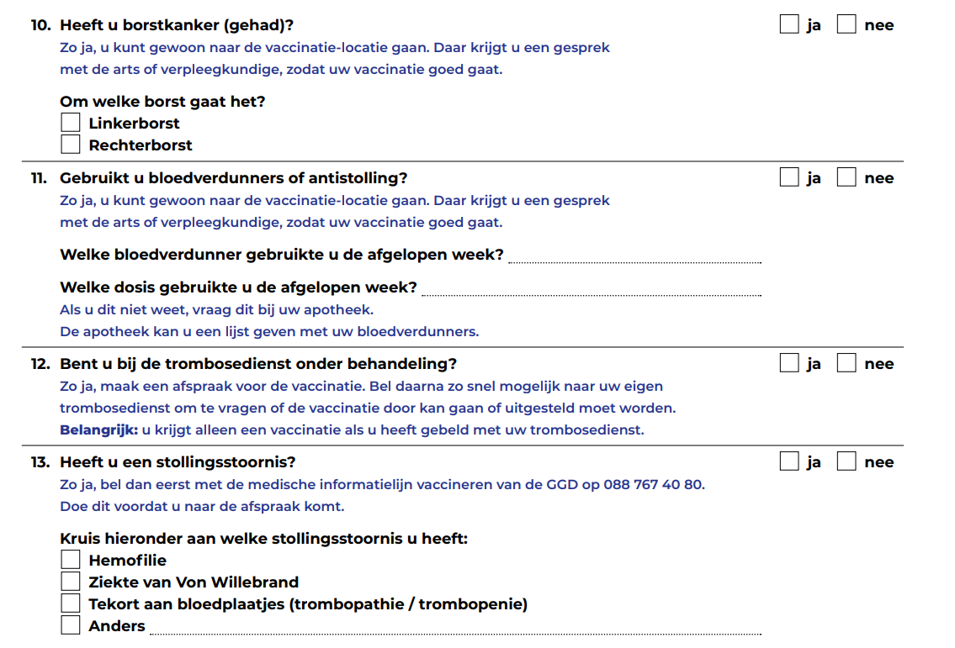

**Researcher:** What would you recommend Manuel to do next?

**Participant:** Usar a app.[Use the app.]

**Researcher:** Have you ever found yourself in a similar situation?

**Participant:** Sim. Por exemplo, quando era... Quando foi para para ir fazer a vacinação do COVID tinha de se preencher um formulário com uma declaração a dizer que se alguma vez tinha tido febre e assim. E algumas algumas perguntas eu não sabia.[Yes. For example, when I was... During the COVID vaccination, you had to fill in a form with a statement saying if you'd ever had a fever and so on. And there were some questions I didn't understand.]

**[STAGE 6 SLIDE 9]**

**Researcher:** “Manuel asks for help from the young man behind the counter. He asks in Dutch if he can explain what is “bloedverdunners of antistolling”,  “trombosedienst onder behandeling”, and “stollingsstoornis” by pointing at the form with his finger. The young man looks surprised. He looks at the next counter, and it is empty. He looks behind, and everyone seems busy. He then tries to start a sentence a couple of times and finally says in English that these are diseases.”What would you recommend Manuel to do next?

**Participant:** Eu diria para conversar com ele e pedir ajuda.[I'd say talk to him and ask for help.]

**Researcher:** Have you ever found yourself in a similar situation?

**Participant:** Não é muito comum, mas sim, já aconteceu. Por exemplo, antigamente nas "belastingdienst", nas finanças, eles não eram nem sequer eram permitidos comunicarem em inglês por causa da clarificação das situações que às vezes a tradução não é assim tão tão boa. E isso era muito complicado.[It's not very common, but it has happened. For example, in the past, in the "belastingdienst", in the tax office, they weren't even allowed to communicate in English because of the clarification of situations that sometimes the translation isn't that good. And that was very complicated.]

**[STAGE 7 SLIDE 10]**

**Researcher:** “Manuel turns to his phone, opens the Google Translate app, and types the words he does not understand.”In your opinion, is Manuel taking a risk by using Google Translate?

**Participant:** Sim**.** [Yes]

**[STAGE 8 SLIDE 11-15]**

**Researcher: “**Manuel turns to his phone, opens the Google Translate app, and types the words he does not understand.”

We are going to use a scale for the following questions:

5 = to a very high degree

4 = to a high degree

3 = to a moderate degree

2 = to a low degree

1 = not at all

Is the scale clear?

**Participant:** Tá bem.[Yes.]

**Researcher:** What level of understanding do you think Manuel has when using the app? Does Manuel understand the text…

5 = to a very high degree

4 = to a high degree

3 = to a moderate degree

2 = to a low degree

1 = not at all

**Participant:** Eu diria 4.[I'd say 4.]

**Researcher:** What degree of risk of significant harm is Manuel exposed to if using the app? Is Manuel’s health at risk?

5 = to a very high degree

4 = to a high degree

3 = to a moderate degree

2 = to a low degree

1 = not at all

**Participant:** Acho que é muito baixo. Acho que talvez um ou dois.[I think it's very low. I think maybe one or two.]

**Researcher:** What degree of trust should Manuel have in these translations? Should Manuel trust these translations?

5 = to a very high degree

4 = to a high degree

3 = to a moderate degree

2 = to a low degree

1 = not at all

**Participant:** Acho que sim, 4.[I think so, 4.]

**Researcher:** What degree of vulnerability do you think Manuel has while using the app? Is Manuel at risk of being vulnerable?

5 = to a very high degree

4 = to a high degree

3 = to a moderate degree

2 = to a low degree

1 = not at all

**Participant:** Mas vulnerável em que sentido?[But vulnerable in what way?]

**Researcher:** De que maneira é que acha que o Manuel se pode sentir vulnerável?[How do you think Manuel might feel vulnerable?]

**Participant:** Por exemplo, eu sou, eu sou de data science. E eu sei que há toda uma, há toda uma recolha de dados. Por exemplo, se eu faço uma fotografia com a app e não sei até que ponto é que não há uma recolha de dados. Eu diria, eu diria baixa. Eu que diria que é 2.[For example, I'm, I'm in data science. And I know that there's a whole, there's a whole collection of data. For example, if I take a photo with the app and I don't know to what extent there's no data collection. I would say, I would say low. I'd say it's 2.]

**Researcher:** Are there any other comments about this scenario or related scenarios you can think of?

**Participant:** Não, acho que estas estas aplicações são só uma uma vantagem muito grande, principalmente para as comunidades de expats que que transitam de um lado para o outro, principalmente quando, quando, quando são línguas que não são tão, tão fáceis de aprender e onde uma grande parte da população consegue comunicar. Mas depois na parte da escrita é muito e muito complicado. Acho que estas apps são... Vêm, vêm, vêm dar uma qualidade de vida muito maior.[No, I think these apps are just a great advantage, especially for expat communities who move from one place to another, especially with languages that aren't so easy to learn and where a large part of the population can communicate. But then writing is very, very complicated. I think these apps are... They came, they came, they came to give us a much better quality of life.]

**[Training - follow-up questions – SLIDES 16-17]**

**Researcher:** Before we end the interview, we also wanted to ask you what sort of training on using these machine translation apps you would find helpful.

What type of information on machine translation would make your life easier when using these apps in health contexts?

For instance, do you feel you need more instructions on how to use the apps? Can you give us an example?

What about information about how to deal with the translations themselves? Do you have an example?

Would it be helpful to understand better the instances when machine translation is not advisable?

**Participant:** Acho que... Acho que a parte de utilização... Acho que são... As aplicações são tão intuitivas que.... Não é? Não havia necessidade de fazer uma formação nesse sentido.[I think... I think using them... I think it's... The apps are so intuitive that.... Isn't it? There is no need for training in that sense.]

**Researcher:** E quanto à privacidade de dados que referiu antes?[What about the data privacy you mentioned earlier?]

**Participant:** Acho que sim. Acho que acho que é importante a privacidade. Porque, imagine só quanto... Quanto mais estes modelos se desenvolverem... Nos dias de hoje a informação é valiosíssima, pois nunca se sabe exatamente para que fins é as informações vão ser usadas. Ou seja, se houvesse, se houvesse uma forma de utilizar a aplicação com consentimento ou sem consentimento de recolha de dados, todas essas coisas sempre estão lá quando uma pessoa carrega. Ok, aceito. Sim, todas essas coisas... Fine print, não é? Como não... pelo menos fazer uma decisão consciente nesse aspeto, acho que essa parte seria mais interessante.[I think that yes. I think privacy is important. Because, just imagine how much... The more these models develop... In this day and age, information is extremely valuable, because you never know exactly what the information is going to be used for. In other words, if there was, if there was a way of using the app with consent or without consent to collect data, all those things are always there when a person clicks “Okay”, “I accept”. Yes, all those things... Fine print, right? Since you don't... At least make a conscious decision in that respect, I think that part would be more interesting.]

**[Closing]**

**Researcher:** Thank you for participating in our research. Our times of analysis and publication are long, but feel free to write to us to obtain the results of this research. Otherwise, we will contact you with the results in due time.